RESEARCH ARTICLE | SEPTEMBER 14 2017

**Real-time bus location monitoring using Arduino** 

Mohammad Y. M. Ibrahim; Lukman Audah

*AIP Conf. Proc.* 1883, 020016 (2017)

<https://doi.org/10.1063/1.5002034>

[](https://pubs.aip.org/aip/acp/article/1883/1/020016/972689/Real-time-bus-location-monitoring-using-Arduino)

[View](https://pubs.aip.org/aip/acp/article/1883/1/020016/972689/Real-time-bus-location-monitoring-using-Arduino)

[Online](https://pubs.aip.org/aip/acp/article/1883/1/020016/972689/Real-time-bus-location-monitoring-using-Arduino)

[](https://pubs.aip.org/aip/acp/article/1883/1/020016/972689/Real-time-bus-location-monitoring-using-Arduino?pdfCoverIconEvent=cite)

[Export](https://pubs.aip.org/aip/acp/article/1883/1/020016/972689/Real-time-bus-location-monitoring-using-Arduino?pdfCoverIconEvent=cite)

[Citation](https://pubs.aip.org/aip/acp/article/1883/1/020016/972689/Real-time-bus-location-monitoring-using-Arduino?pdfCoverIconEvent=cite)

[CrossMark](https://pubs.aip.org/aip/acp/article/1883/1/020016/972689/Real-time-bus-location-monitoring-using-Arduino?pdfCoverIconEvent=crossmark)

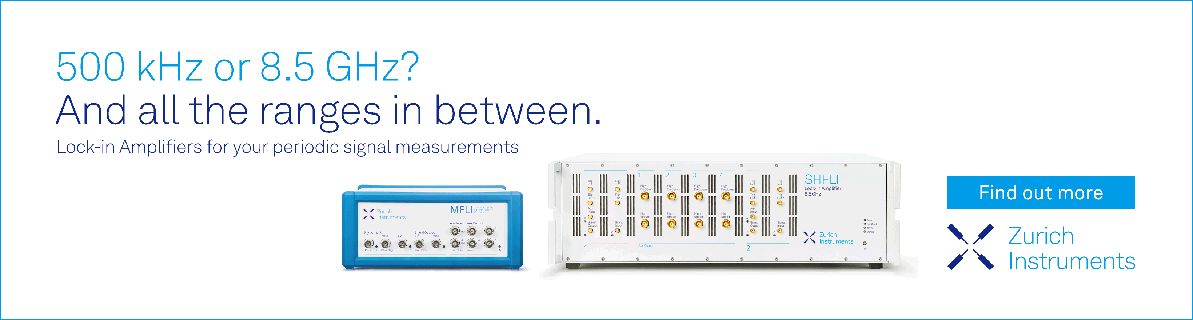

18 October 2023 09:13:29

**Articles You May Be Interested In**

[Automated barrier system and sanitization](https://pubs.aip.org/aip/acp/article/2857/1/020015/2907231/Automated-barrier-system-and-sanitization)

*AIP Conf. Proc.* (August 2023)

[Design and implementation of Arduino based autonomous school van with student monitoring system](https://pubs.aip.org/aip/acp/article/2829/1/060005/2902163/Design-and-implementation-of-Arduino-based)

*AIP Conference Proceedings* (July 2023)

[Enhancing the role of the waterway public transport system in Ho Chi Minh city as part of urban space development following the green Urbanism](https://pubs.aip.org/aip/acp/article/2560/1/020015/2891880/Enhancing-the-role-of-the-waterway-public)

*AIP Conference Proceedings* (May 2023)

18 October 2023 09:13:29

**Real-Time Bus Location Monitoring Using Arduino**

Mohammad Y. M. Ibrahim1, a) and Lukman Audah2, b)

1*Exquisite Resources Sdn. Bhd., 40100 Shah Alam, Selangor, Malaysia*

2*Wireless and Radio Science Centre (WARAS), Faculty of Electrical and Electronic Engineering, Universiti Tun Hussein Onn Malaysia, Parit Raja, 86400 Batu Pahat, Johor, Malaysia*

b)Corresponding author: [hanif@uthm.edu.my](mailto:hanif@uthm.edu.my)

[a)yassir.87@hotmail.com](mailto:a)yassir.87@hotmail.com)

**Abstract.** The Internet of Things (IoT) is the network of objects, such as a vehicles, mobile devices, and buildings that have electronic components, software, and network connectivity that enable them to collect data, run commands, and be controlled through the Internet. Controlling physical items from the Internet will increase efficiency and save time. The growing number of devices used by people increases the practicality of having IoT devices on the market. The IoT is also an opportunity to develop products that can save money and time and increase work efficiency. Initially, they need more efficiency for real-time bus location systems, especially in university campuses. This system can easily find the accurate locations of and distances between each bus stop and the estimated time to reach a new location. This system has been separated into two parts, which are the hardware and the software. The hardware parts are the Arduino Uno and the Global Positioning System (GPS), while Google Earth and GpsGate are the software parts. The GPS continuously takes input data from the satellite and stores the latitude and longitude values in the Arduino Uno. If we want to track the vehicle, we need to send the longitude and latitude as a message to the Google Earth software to convert these into maps for navigation. Once the Arduino Uno is activated, it takes the last received latitude and longitude positions’ values from GpsGate and sends a message to Google Earth. Once the message has been sent to Google Earth, the current location will be shown, and navigation will be activated automatically. Then it will be broadcast using ManyCam, Google+ Hangouts, and YouTube, as well as Facebook, and appear to users. The additional features use Google Forms for determining problems faced by students, who can also take immediate action against the responsible department. Then after several successful simulations, the results will be shown in real time on a map.

# INTRODUCTION

A shuttle bus service, especially in the educational institution, has been well established in Malaysia. Most of the universities and residential colleges have outsourced their shuttle bus service to the public bus companies, and the majority of them have a proper timetable. As one of the most affordable means of transport to commute to campus, the shuttle bus serves a vast majority of students in most educational institutions.

When traveling in buses, travelers usually want to know their accurate arrival times, but the bus timetable is lacking reliability in terms of punctuality. Hence, the bus arrival information system is a service that aims to provide a more convenient shuttle bus service, especially for the communities in the educational institution, the majority of which are highly dependent on buses for transportation. The arrival system will consist of three major components.

* Supported by sophisticated GPS technology, the system will be able to provide real-time locations of the moving buses.
* Besides depending on the GPS data, bus users can have an overview on the bus’s latest “checkpoints,” which refer to points along the bus service route.
* The latest “checkpoints” provide reliable information for the users to forecast approaching buses.

*Advances in Electrical and Electronic Engineering: From Theory to Applications*

AIP Conf. Proc. 1883, 020016-1–020016-10; doi: 10.1063/1.5002034

Published by AIP Publishing. 978-0-7354-1563-8/$30.00

This project aims to develop a prototype system for bus monitoring that is able to receive GPS data, detect the real-time locations of buses, and estimate their arrival times. For case study purposes, the prototype system is customized to the application in University Tun Hussein Onn Malaysia (UTHM), mainly for students living in Taman University and inside the UTHM campus.

18 October 2023 09:13:29

In 2011, C. H. Zhou and Z. G. Gao completed a project titled “A Real-Time Information System for BRT Based on GPS/Signpost Compound Navigation.” This project has provided real-time transit information for the bus rapid transit (BRT) system based on GPS compound automatic vehicle location (AVL) technology [1]. Compared with the traditional signpost system, the upgraded system locates buses’ accurate positions of arrival and departure at stops via the existing BRT platform facility, which is called the platform screen doors (PSDs) system. Only when the bus stops at a depot within a permissible error range can the driver open or close PSDs using onboard transmitters to send out signals, which can be received by platform receivers mounted on the platform’s edge. Using the existing resources, the upgraded system combines GPS and signposts—called PSDs system in this article—to provide real-time information about transit services to the passenger’s BRT system. The passengers are satisfied with real-time transit information, particularly with accurate information of buses’ arrivals at and departures from their stops. This system is not suitable in the campus setting because it uses an infrared system, similar to an RF system, which can detect objects in short range [2], allowing the possibility of the unauthorized reading of passports and credit cards. Tags are application specific. RFID tags are usually larger than barcode labels [3] and can make up for the drawbacks of failing to disseminate bus locations because of missing data from GPS.

Next, in 2013, L. S. Ai’s study, “People Tracking System Using Global Positioning System and Global System for Mobile Communication,” proposed a small-scale, real-time, high-frequency bus location-tracking system. By using smartphones as tracking devices, the proposed approach entailed the ability to track vehicles automatically in real time through tailor-made application without requiring external power within eight-hour operating periods. In addition, a customized map transformation was proposed to cover the areas where the locations were not available through standard map services such as Google Maps [4]. The system required EDGE/3G data for communication [5]. By the end of 2014, K. Sujatha and K. J. Sruthi completed the design and development of an Android mobile- tracking system [6]. In 2014, S. Sankaranarayanan and P. Hamilton created a project called the “Mobile-Enabled Bus Tracking” system [7]. The system used RFID to find the updated locations of transportation [8]. The system also used database SQL for stored data and transmitted maps to the users on mobile [9]. This system used mechanisms such as SMS, GSM networks, and RFID [10]. The system’s technology used GPS for tracking devices and then sent the information to the centralized control unit (CCU). The CCU would then send the information to RD receivers at bus stops and users’ devices. The information could be retrieved through SMS. Through Android applications and LED lighting at bus stops, the buses’ updated locations could be seen from Google Maps [11]. The GPS coordinates of the buses were sent to the CCU server for information processing to get the buses’ estimated times of arrival [12]. This application system is useful for users because it can save them more time to reach their destinations. In this project, Google Maps is more complex than Google Earth because it needs the application programming interface (API) key [13]. The project used Web applications and servers to store data and appear as maps to users on Android systems [14]. The mechanism is more complicated because the information must be sent to the server for data processing,

which can take time to send back to the users [15].

In 2016, M. Kolaskar et al. created a paper that described the design and implementation of a real-time and offline GPS tracker using an Arduino [16]. Previously, real-time and offline GPS tracker systems were implemented separately.

# PROBLEM STATEMENT

There are no easy methods for students who live on campus and outside or near the campus to check bus locations in real time. Bus travelers want to know the buses’ accurate arrival times because they tend to maximize their personal time. Instead of going out a lot earlier to wait for the bus, they usually leave their doorsteps on the dot with the bus’s scheduled time. Despite the bus timetable being freely available on the Web, bus operators often do not follow it accordingly, and other factors (e.g., real time, breakdowns) have proven that the schedule provides limited information. Bus users become frustrated when they miss that one bus trip before the next bus service that will cause them to be late for their arrangements. Excessively long waiting times at bus stops may drive away anxious travelers and make them reluctant to take buses. At the end of the day, they decide to depend on their own transportation to commute to the campus, which results in the increasing traffic flow on the road.

# PROJECT SCOPE

18 October 2023 09:13:29

The scope of this project is only limited from Taman Universiti to the UTHM campus. All the surveys and evaluation have been conducted on the campus. An Arduino Uno and GPS are used as the main microcontrollers. The Arduino Uno reads the GPS information. The Arduino Uno and GPS module are used together with the GpsGate software to determine locations and navigation on maps. Bus navigation provides information on the time intervals from current to new locations and the distances between bus stands. The GPS is used as an input to provide real-time positioning data and the buses’ estimated times of arrival (ETA). ManyCam and Google+ Hangouts are used as the mediums to broadcast live video streaming of bus navigation routes. Bus users can view the live broadcast from YouTube and Facebook.

# SYSTEM DESIGN

The project design is divided into three phases, which are (1) the survey phase, (2) the hardware-designing phase, and (3) the software-designing and valuation phase.

Figure 1 show the project’s workflow. Figure 1 shows the first phase, where a survey is done to identify the problems and the existing solutions faced by UTHM students using transportation. After the problems are identified, the next phase is the hardware design phase. In this phase, there are multiple platforms involved, specifically the microcontroller Arduino Uno integrated with Adafruit GPS. Then research is conducted on the suitability and cost of the hardware and software to be used in this system. After that, a proposal and an evaluation by panels also determine whether this project is practical or not. If it is practical, the second phase of the design may proceed. In the second phase, a circuit diagram design using the Fritzing software for schematics is created. Then a coding sequence to connect the Arduino Uno and Adafruit GPS is created to determine locations using Google Earth. After that, a connection is physically made between Arduino Uno and Adafruit GPS. Then the data received from a satellite in real time is investigated and troubleshot for testing and functionality. If it does not work, we find steps to solve the problem. If it works, we proceed to the next phase. The third phase involves building a complete physical prototype and demonstrating the system, using the ManyCam software to broadcast maps from Google Earth onto YouTube and social media websites like Facebook.

Figure 2 shows about technical part of the project’s. The first step involves an Arduino Uno, which is a microcontroller integrated with other devices or sensors. The second step is Arduino Uno’s is a microcontroller act as a small control processor unit also can integrated with Adafruit GPS kit to get updated position signal of current location like an latitudes and longitude. The third step, after receive current location, it will be sends the signal, converted into GPRMC form, to GpsGate to form latitudes and longitude via serial COM ports. It also sends to GpsGate for received the location on map for real view using Google Earth. In the fourth step, a GPS signal is formed by GpsGate, interpreting the degrees and showing the updated positions in Google Earth. The signal will continue to update in sequences; an interval can be set every 1 to 60 seconds. In the fifth step, ManyCam records the live event, and the user can change the effects as well as customize the resolution size. Manycam also should be integrated with Google Hangout and YouTube as live streaming and broadcast for user view. YouTube live streaming can be set to public or private mode. YouTube streaming via Google Hangout enables video calls. Facebook is a medium of media social among users. Facebook can make live chat for discussion and makes it easy for users to discuss the problem of buses they encountered in the current location. Finally, the link is created by YouTube and can be shared on any social media website such as Facebook, Twitter, and so on. Feedback forms are created in Facebook using Google Forms for any suggestions or complaints from students requesting immediate action.

18 October 2023 09:13:29

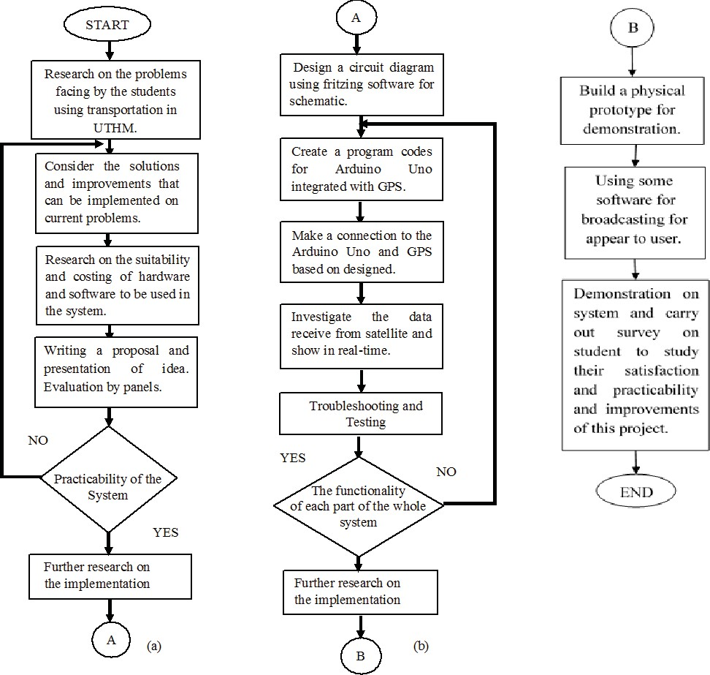

**FIGURE 1.** The project management flowchart.

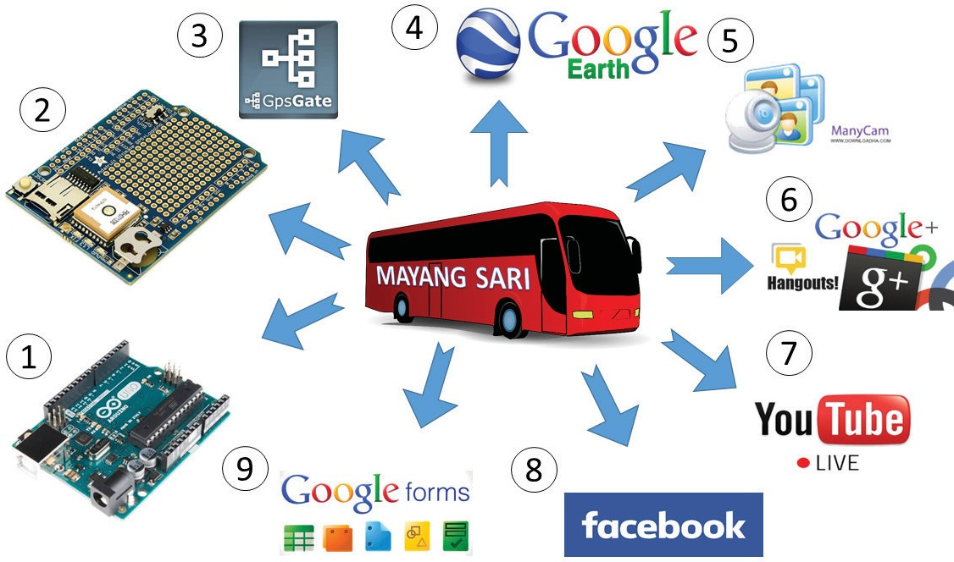

**FIGURE 2.** The graphical project workflow based on the used hardware equipment and services.

Figure 3 shows the workflow of coding between hardware, such as sending and receiving commands, starting with initializing a complete interconnection circuit between the Arduino and the GPS. Then the Adafruit GPS library is defined, and a request is sent through a signal in serial port communication to the computer. We begin the GPS starting value at 9600 to get a satellite signal; if not, the value will start again from the first process. Furthermore, the GPS transmits a command regarding the updated location. The process repeats until the device is switched off.

18 October 2023 09:13:29

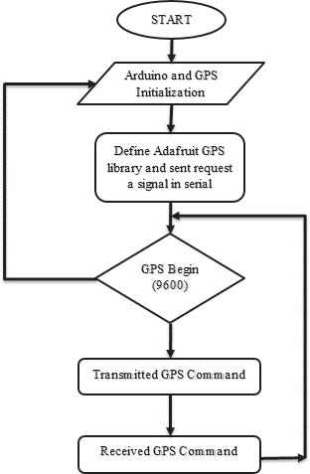

**FIGURE 3.** Arduino Uno code programming workflow.

Figure 4 shows a completed hardware circuit configuration between an Arduino Uno and Adafruit GPS with a computer for serial connection. In the wiring connection between an Arduino Uno and Adafruit GPS, the red wire represents the power supply +5v and the black wire represents the ground connection. The yellow wire is an Arduino Uno transmit signal (Tx) to the GPS’s receive signal (Rx), and the green wire is an Arduino Uno receive signal (Rx) connected to the GPS’s transmit signal (Tx). It will work successfully.

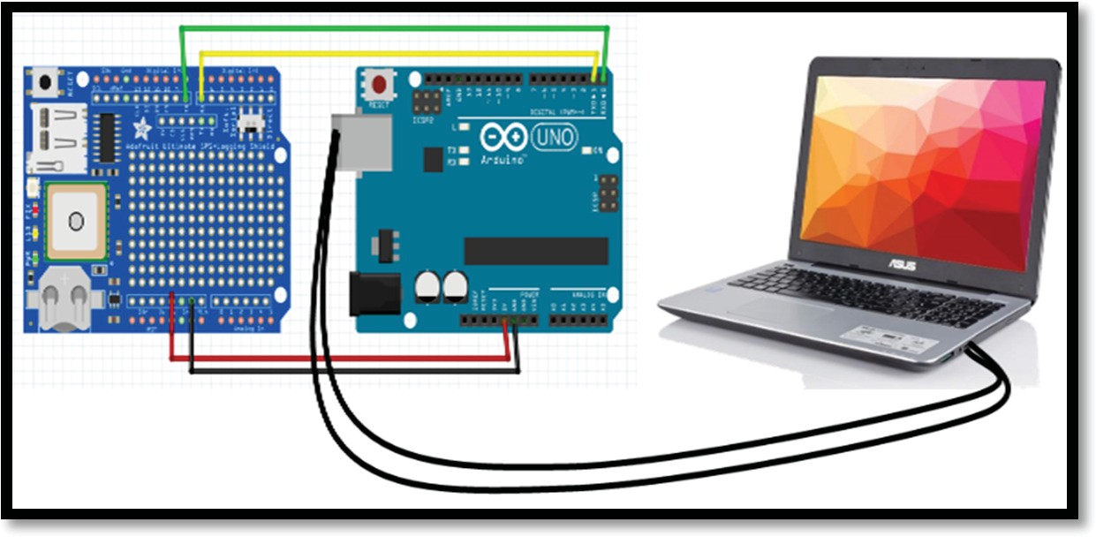

**FIGURE 4.** The complete system hardware circuit configuration.

Figure 5 shows the integration between the hardware and Google Earth. The hardware is connected to a computer for serial communication. The GpsGate software works to give a connection between the hardware and Google Earth as an internal server using COM port 3. Then the updated position will appear directly on maps in real-time navigation. An Internet connection is needed only for screening maps.

18 October 2023 09:13:29

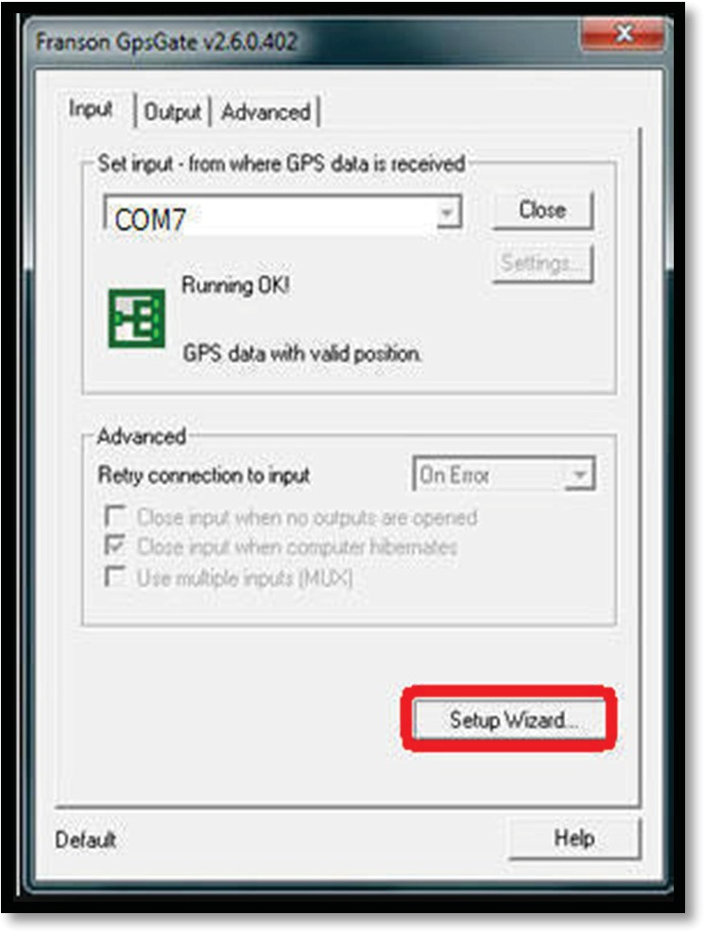

**FIGURE 5.** GpsGate client setting configuration.

# PROTOTYPE RESULTS

The bus location applications are tested on their reliability to perform all the desired operations in real time and then broadcast the live results to the users. The hardware is tested on its functionality, accuracy, and compatibility with the software. The whole system is then tested on the stability of the communication between the hardware and the software. The YouTube and Facebook live streaming are also tested with live chat features for comments or complaints from users. Besides that, troubleshooting is performed to fix the problems encountered during system development. Analysis and observation are done to make sure that everything is running according to the planned objectives.

Figure 6 shows the route from Taman University to the UTHM main campus in Google Earth. The received signal from the GPS device is in “GPRMC”, “GPGGA”, and “GPGSV” format. Then the GPS coordinates are translated, displaying the updated positions on a map. The Arduino Uno updates every second. For the updated positions received by the GPS, GpsGate provides the option to choose Google Earth as a map platform to display the current latitude and longitude coordinates. Furthermore, the received signal from GpsGate will be translated into an icon that reads “Bus UTHM” on the Google Earth map for real-time navigation.

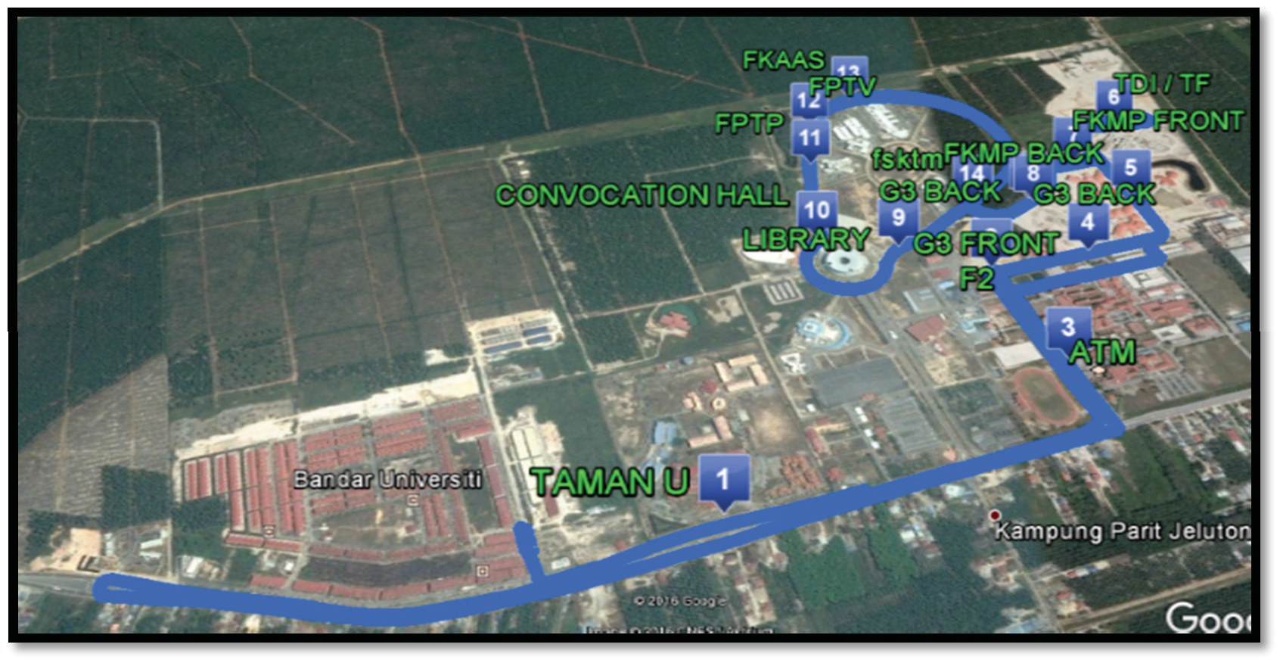

18 October 2023 09:13:29

**FIGURE 6.** The bus service route in the Google Earth software.

Figure 7 shows the YouTube stream using the ManyCam software. This software records the computer screen, which is broadcast to users. This software can also resize the screen resolution from 144p to 720p. It can also record live footage and allow the customization of screen size and effects such as transitions and many other options. The title bar, which reads “KATSINI UTHM” at the bottom of the image, can also be customized. The blue color line is route for buses is fixed. Number of buses can be fixed randomly named as a ‘uthm1’, ‘uthm2’, ‘uthm3’.

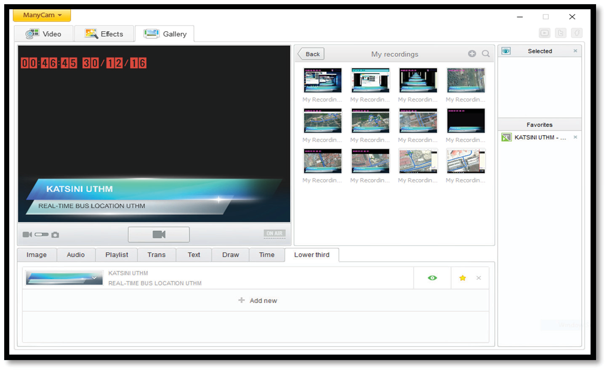

**FIGURE 7.** ManyCam software setting configuration for Youtube live streaming.

Figure 8 shows the mainframe of Google+ Hangouts. It is a broadcast medium for users, which appears in the ManyCam software. This software has some features like chatting, video calls, and so on. This software can also do live broadcasts on YouTube. A simple setting process eases the streaming process of videos with resolutions between 144p and 720p.

18 October 2023 09:13:29

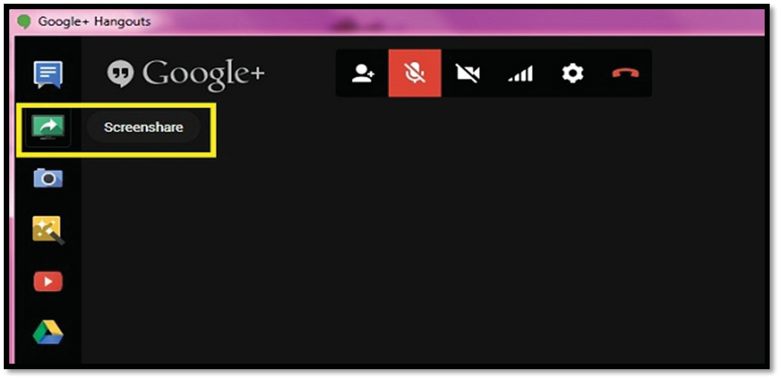

**FIGURE 8.** Mainframe view of Google+ Hangouts.

Figure 9 shows the live stream as it appears to users from Google+ Hangouts and YouTube. The live stream shows real-time navigation. The resolution can be adjusted from 144p to high-definition (HD) 720p, but video quality also depends on Internet speed, which is just between 100KB/s and 130KB/s. Nowadays, there are more advanced Internet connections with high 4G speed, so Internet usage is not a problem.

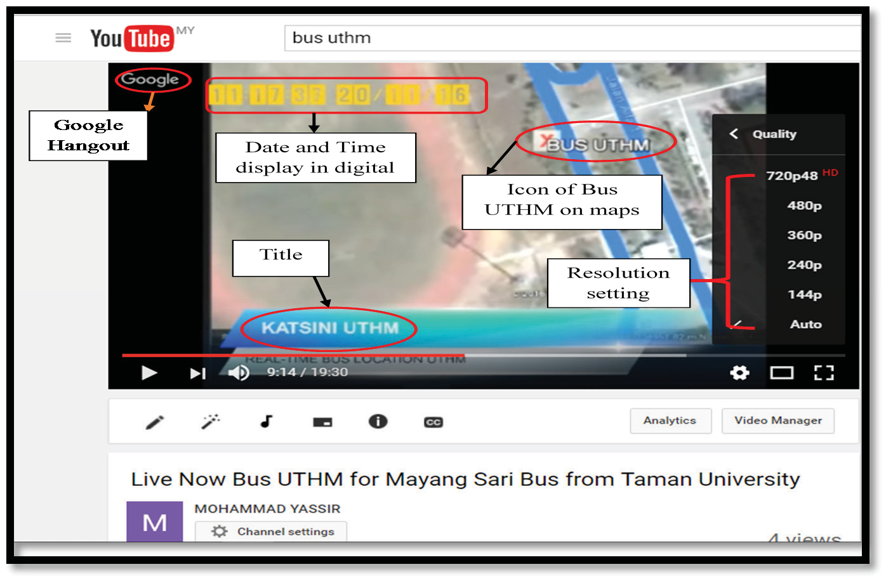

**FIGURE 9.** Youtube live video streaming of the bus current location on the service route.

Figure 10 shows Facebook as a more accessible medium for the user. Nowadays, many people spend more time in social media. It is relevant that the user can also view maps on Facebook. Facebook can also give users easier access and allow them to give comments, report bus issues, and make complaint forms for immediate action.

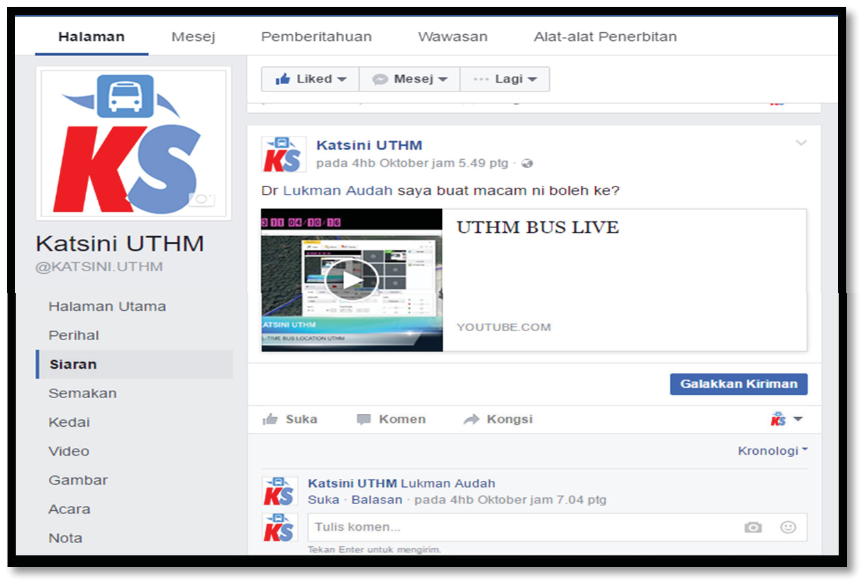

18 October 2023 09:13:29

**FIGURE 10.** Facebook page as social platform for the Katsini bus location monitoring system.

# CONCLUSION

The results of this project show that this developed system provides many advantages and benefits for the commuting student. Among the advantages of this system are the application of YouTube and Facebook, easy-access social media websites. It is easy to make a proper complaint form similar to a hard-copy form by logging into Siswamail and sending the form to the responsible UTHM department. The streaming is live, and the video is automatically stored in YouTube and can be viewed again. The system’s new feature for uploading files like photos, videos, or voice recordings easily provides evidence for responsible departments to take action.

# ACKNOWLEDGMENTS

The authors would like to thank the Ministry of Education Malaysia under Research Acculturation Grant Scheme (RAGS) and the Universiti Tun Hussein Onn Malaysia for the generous financial support.

# REFERENCES

1. C. H. Zhou And Z. G. Gao, *Proceedings of the Int. Conf. Logist. Eng. Intell. Transp. Syst. (LEITS 2010).* (IEEE, 2010). pp. 100–103.
2. R. Ramani, S. Valarmathy, N. Suthanthiravanitha, S. Selvaraju, M. Thiruppathi, and R. Thangam. [Int. J. of Intelligent Systems](http://dx.doi.org/10.5815/ijisa.2013.09.10) [and Application](http://dx.doi.org/10.5815/ijisa.2013.09.10). **9**, 86–93 (2013).
3. G. Radinski And A. Mileva. *7th ICT Innovations Conference.* (2015). pp. 21-30.
4. S.A. Lim, Ph.D thesis, Universiti Teknologi Malaysia, Johor Bahru, 2013.
5. S. Lee, G. Tewolde, And J. Kwon. *Proceedings of IEEE World Forum On Internet of Things (WF-IoT 2014).* (IEEE, 2014). pp. 353–358.
6. K. Sujatha, P. V. Nageswara Rao, and K. J. Sruthi. *Proceedings of 1st Int. Conf. on Networks and Soft Computing (ICNSC 2014).* (IEEE, 2014). pp. 231–235.
7. S. Sankarananrayanan and P. Hamilton. *Proceedings of 2nd Int. Conf. on Information and Communication Tech. (ICoICT 2014).* (IEEE, 2014). pp. 475–480.
8. N. Oluwatobi, “A GPS based automatic vehicle location system for bus transit,” (1999).
9. M. Sneha, C. N. Urs, S. Chatterji, M. S. Srivatsa, K. J. Pareekshith, And H. A. Kashyap. *Proceedings of Int. Conf. on Contemporary Computing and Informatics (IC3I 2014).* (IEEE, 2014). pp. 724–727.
10. L. Singla And P. Bhatia. Proceedings of *IEEE Int. Conf. on Computer, Communication and Control (IC4 2015).* (IEEE, 2015). pp. 1-6.
11. C.L. Schweiger, *Real-Time Bus Arrival Information Systems* (Transportation Research Board, Washington D.C.,2003).
12. S. Ahmed, S. Rahman, and S. E. Costa, Ph.D Thesis, BRAC University, Dhaka, 2015.

18 October 2023 09:13:29

1. M. Nemat. Gps Sensor, Honours Project (COMP 4905) Report, Carleton University, Ottawa, 2010.
2. N. Chadil, A. Russameesawang, and P. Keeratiwintakorn. [*Proceedings of 5th Int. Conf. on Electrical Engineering/Electronics*](http://dx.doi.org/10.1109/ECTICON.2008.4600454)*,* [*Computer, Telecommunications and Information Tech. (ECTI-Con 2008)*](http://dx.doi.org/10.1109/ECTICON.2008.4600454)*.* (IEEE, 2008). **1**, pp. 393–396.
3. Dhivyabharathi, B. A. Kumar, and L. Vanajakshi. *Proceedings of IEEE International Conference on Intelligent Transportation Engineering (ICITE 2016).* (IEEE, 2016). pp. 18–22.
4. M. Kolaskar et al., Imperial J. of Interdisciplinary Research. **2**, 94–96 (2016).